**ZABBIX setup after installation**

These are following steps need for the monitoring of the host

1. Add new host

2. Add/edit Items

3. Add/edit Trigger

4. Configuration for email alerts notification

5. Create action for alerts of the event

1. **Add new host**

(I) Open zabbix server dashboard URL and login with admin credantial to configure zabbix server.

(II) Now follow the steps as shown in the below snapshots.

(a) Click on **Configuration > Hosts > create host**

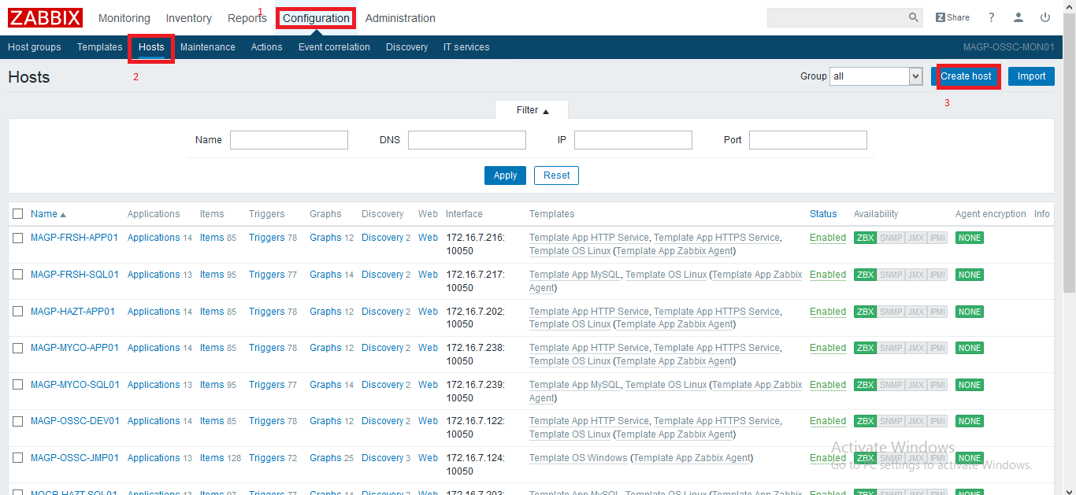

(b) Enter following details

1. Client **Hostname**

2. **Visible name**

3. Select **group** for the client

4. **IP address** of the client

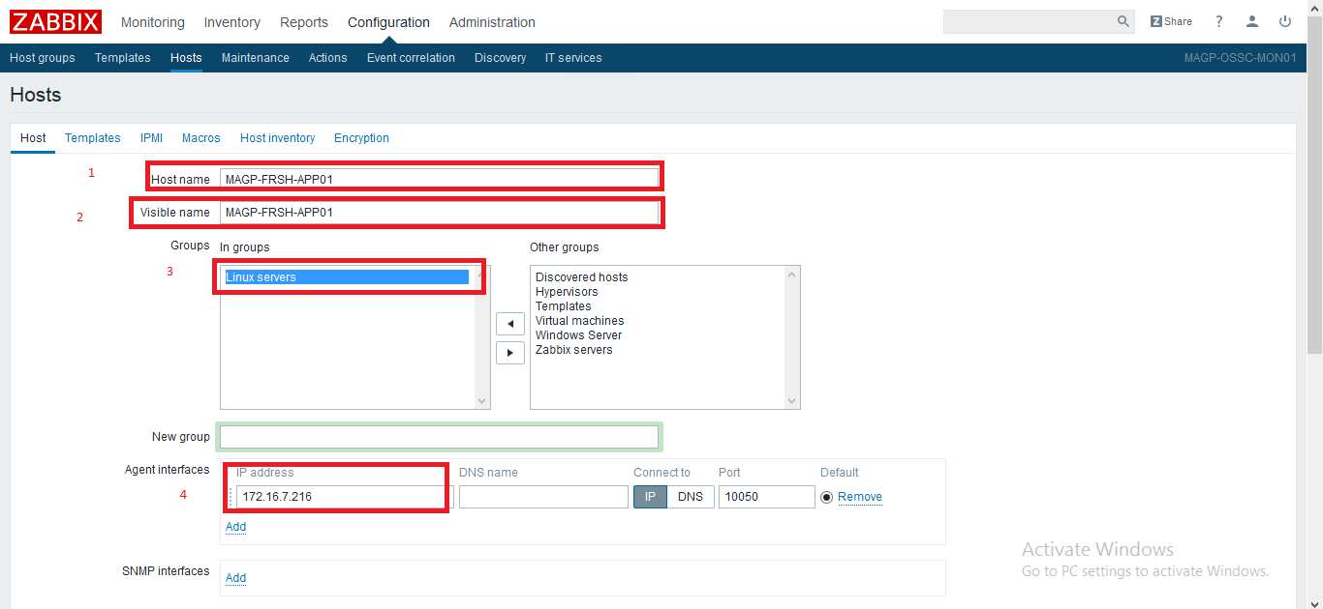

(c) To enable this host for monitoring **select check box to enable the host**

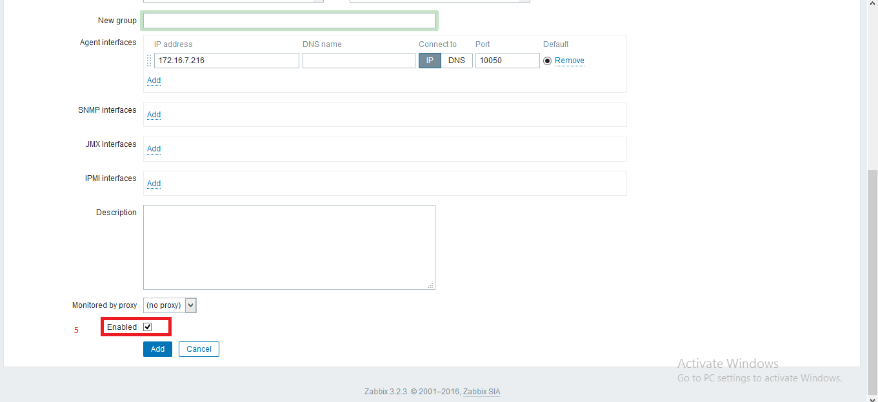

(d) Now click on templates tab .

Click select to choose templates from the list .

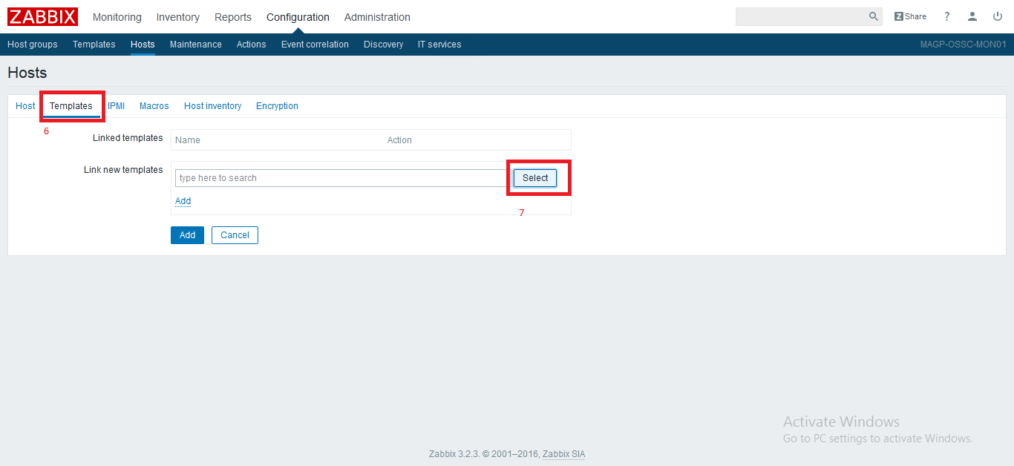

(e)Now select the template to apply on this host and click on select.

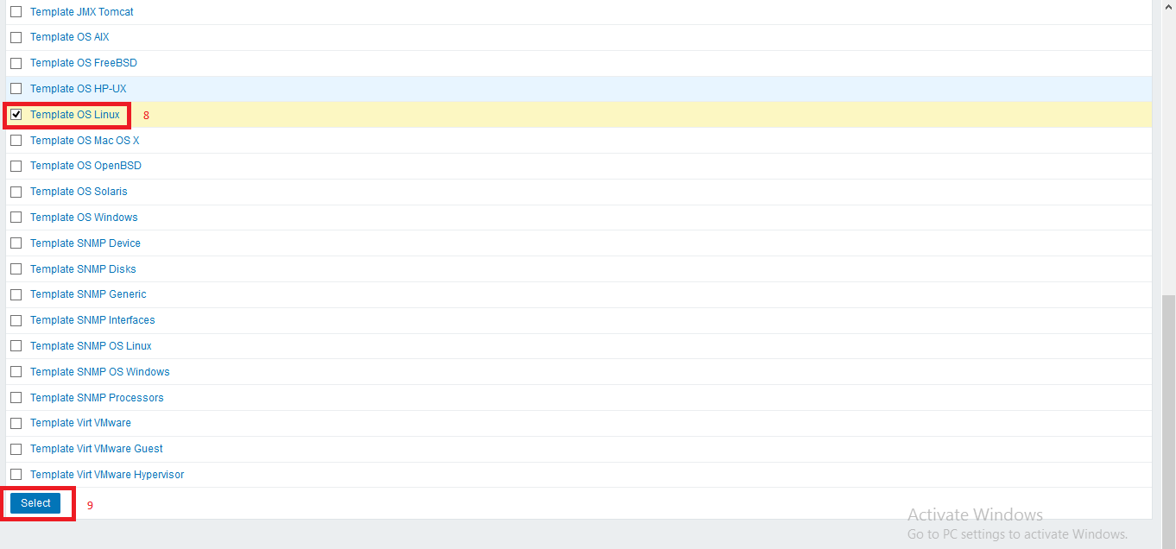

(f) Now after selecting template click on Add

After adding template on this host , click on Add option to add this host .

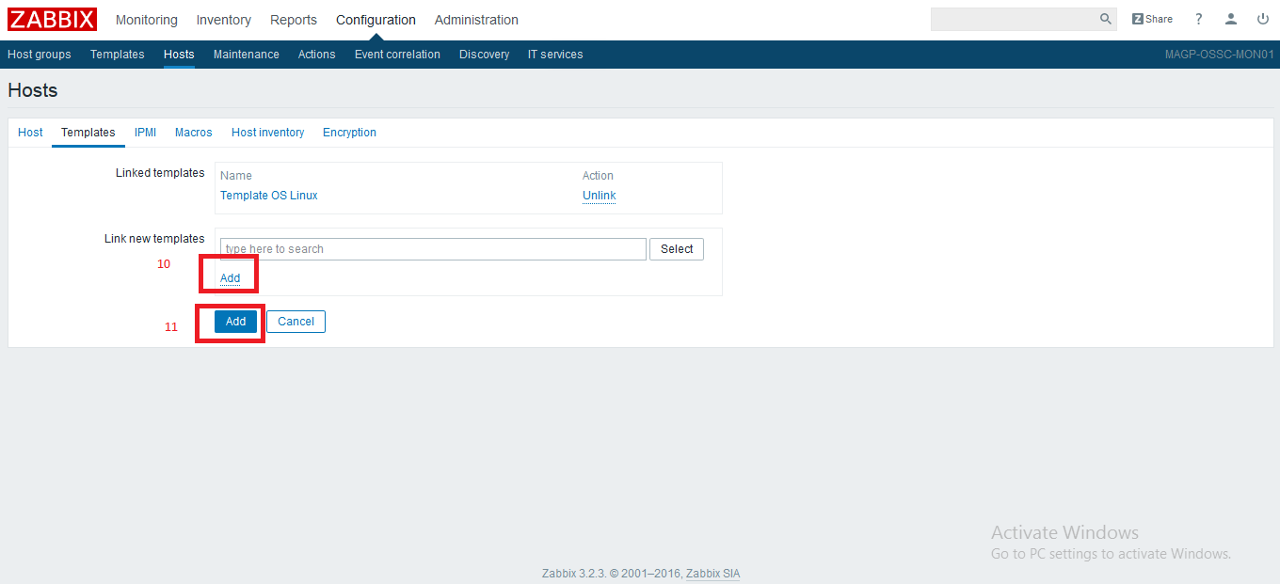

Now a new host has been added .

To see this host click on **Configuration > Hosts .**

After adding host and applying default template on it according to operating system , we can add new items or edit existing ones.

**2. Add/edit Items**

To add an item click on **Configuration > Host**

Here you will able to check lsit of the added host .Now select host in that you want to create item.and follow below steps as shown in the snapshot

(a) Click **Configuration > Host > Application**

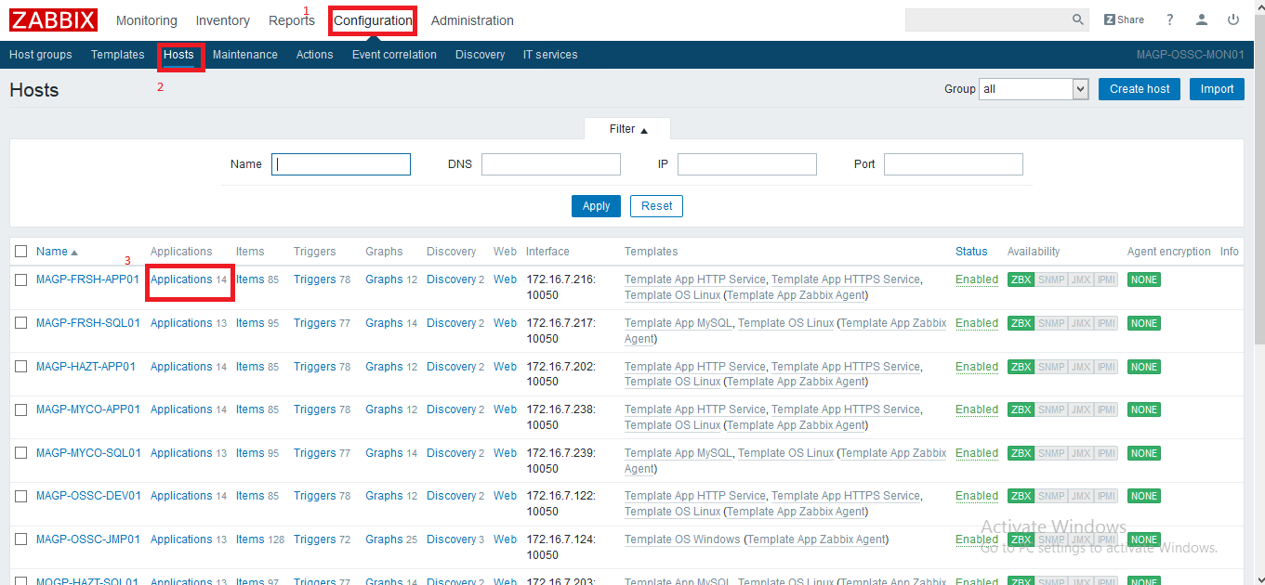

(b) Now select application and **click on Items** to check list of configured items

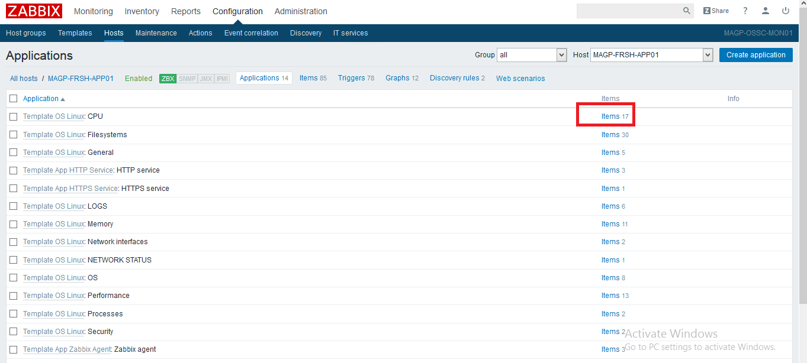

(c) Now click on **create item**

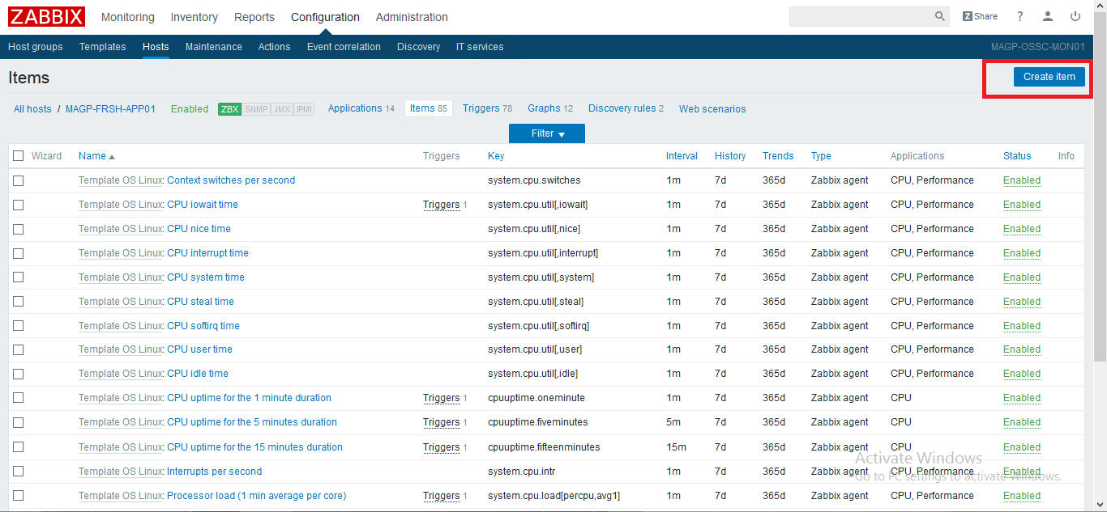

(d) Now on this steps fill below details

1. Item name

2. Type of the item (depend on your requirement)

3. Click on select to add here item key and its value

(follow steps e and f here)

4. Type of information that will be monitored by zabbix

5. Data type

6. Unit of collected data (enter if required)

7. Update interval time

8. History storage

9. Trend storage time

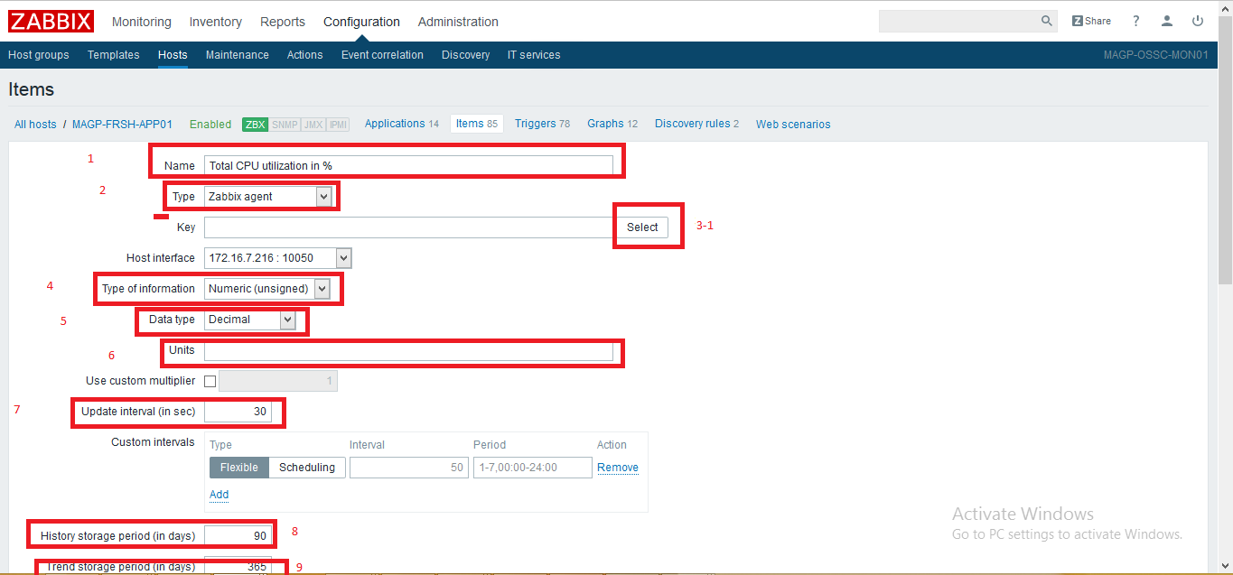

(e) follow this steps with above step 3

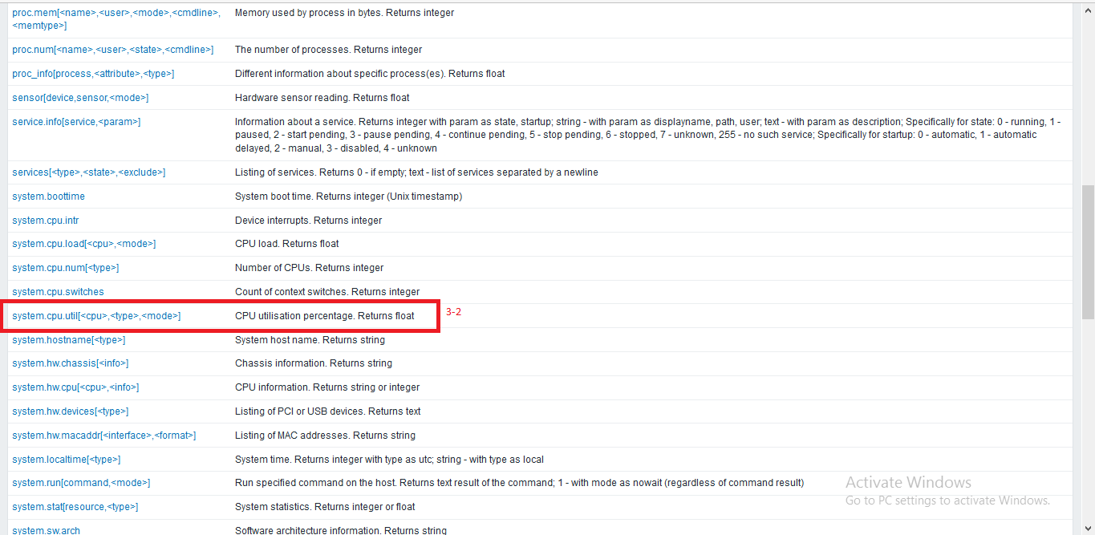

(f) follow this steps with above step 3

Now edit the value of the item key

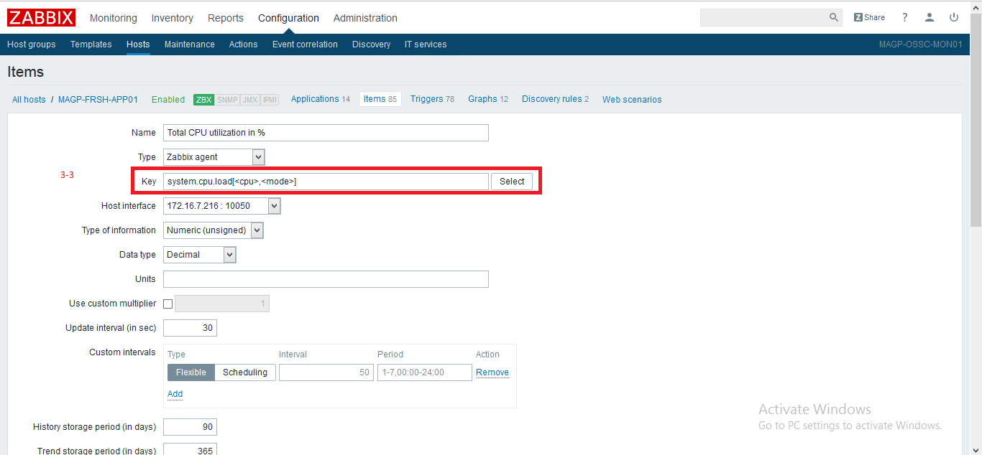

(g)

(10) Now select application name

(11) select check box to enable this item

(12) Click on Add to add this item.

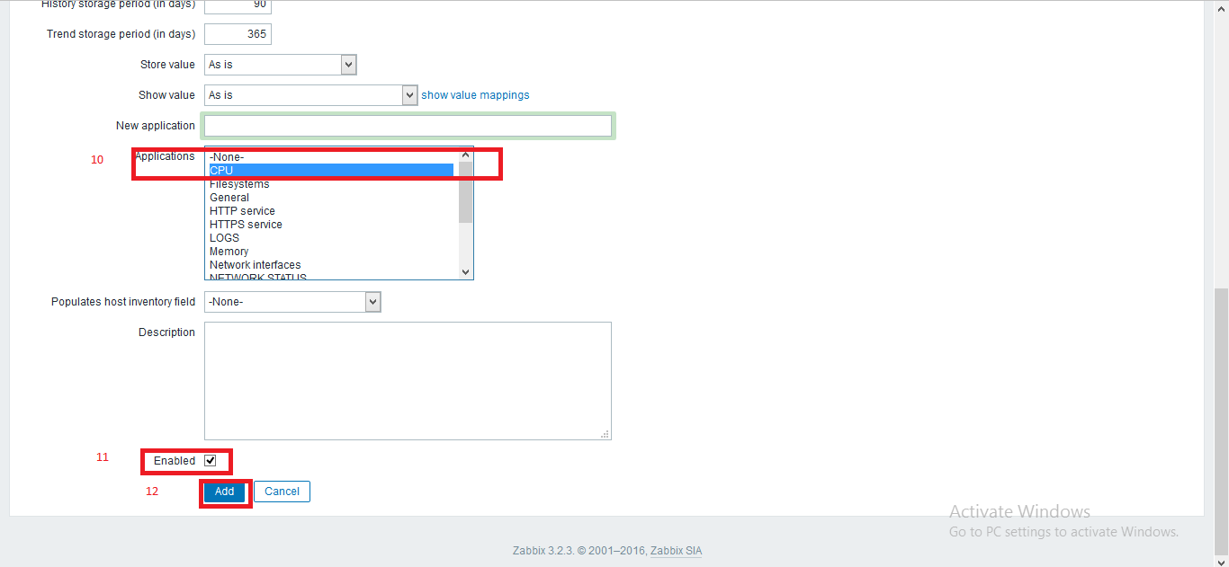

Now an item has been added.

Similarly we can edit item key value and other properties by selecting item from the Appliction .

Now we can create trigger for the created item

3. **Add/edit Trigger**

(a) Click on **Configuration > Hosts**

select host and click on **Triggers**

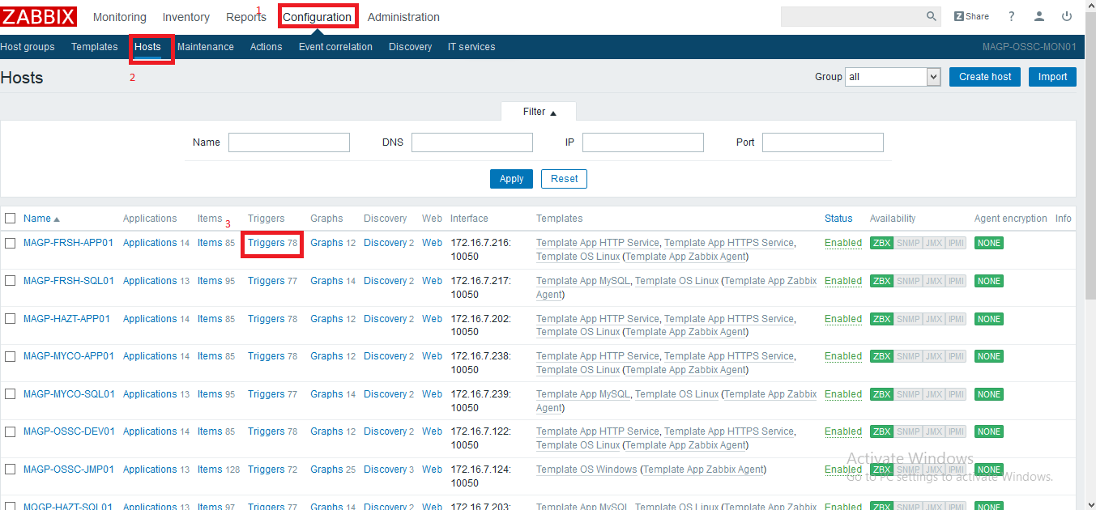

(b)Click on **create trigger**

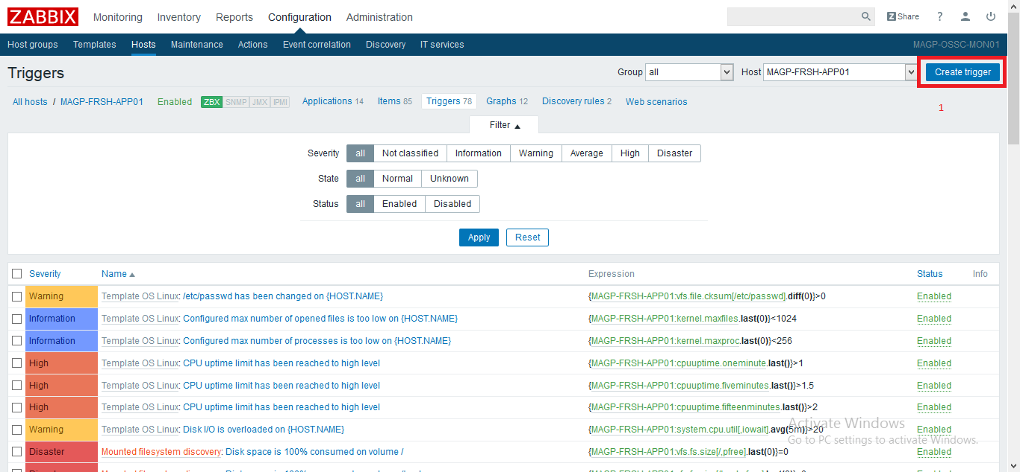

(c) Enetr below details

1. Name of the trigger

2. Severity of the trigger

3. click on Add to add item key and expression

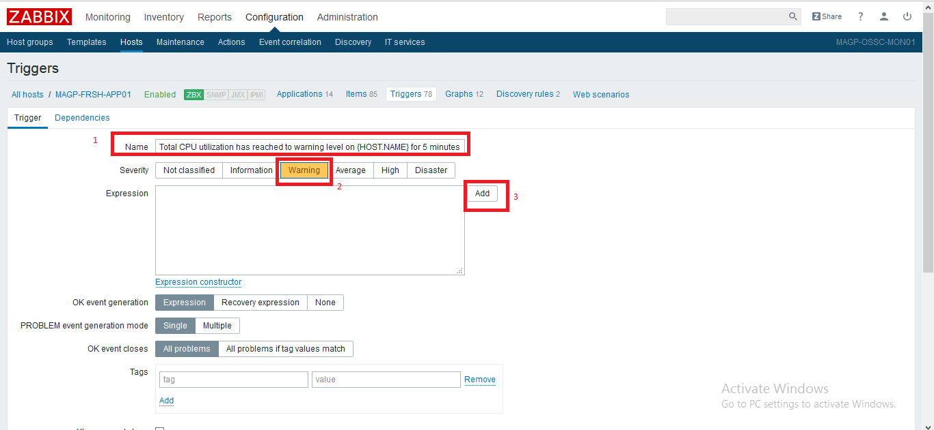

(d) Now click on select to select item for this trigger.

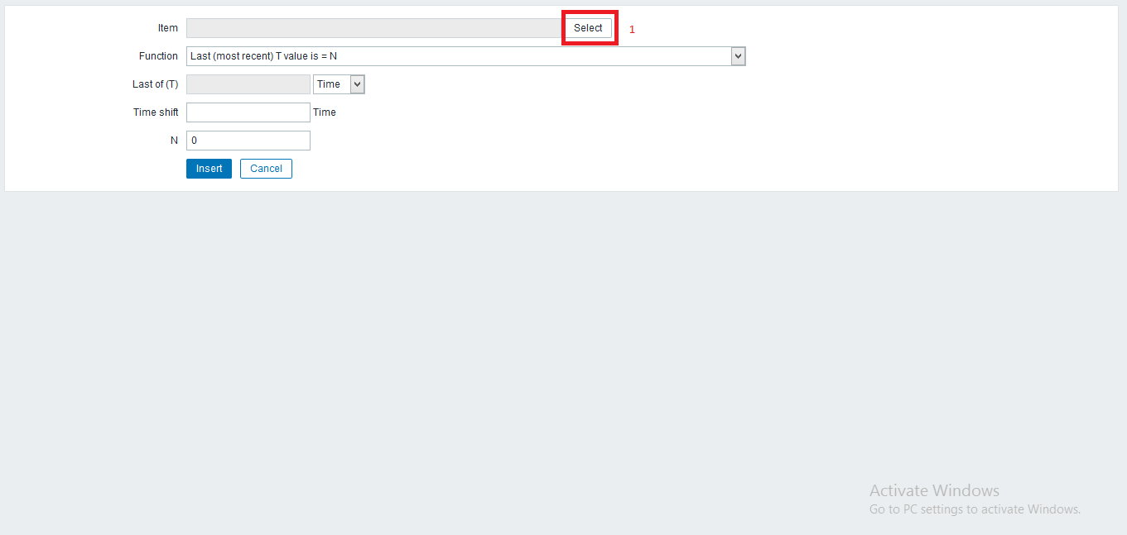

(e) Select item that we have created before.

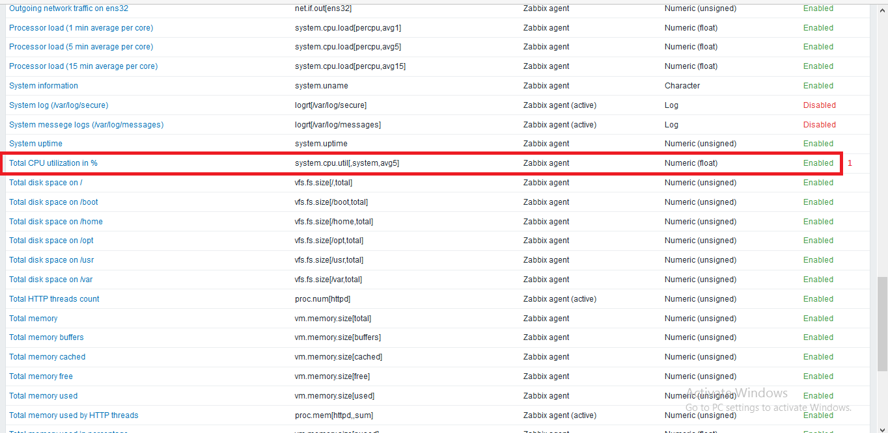

(f)

1.Now choose function from drop down list

2. Enter threshold value for the trigger.

3. click on Insert

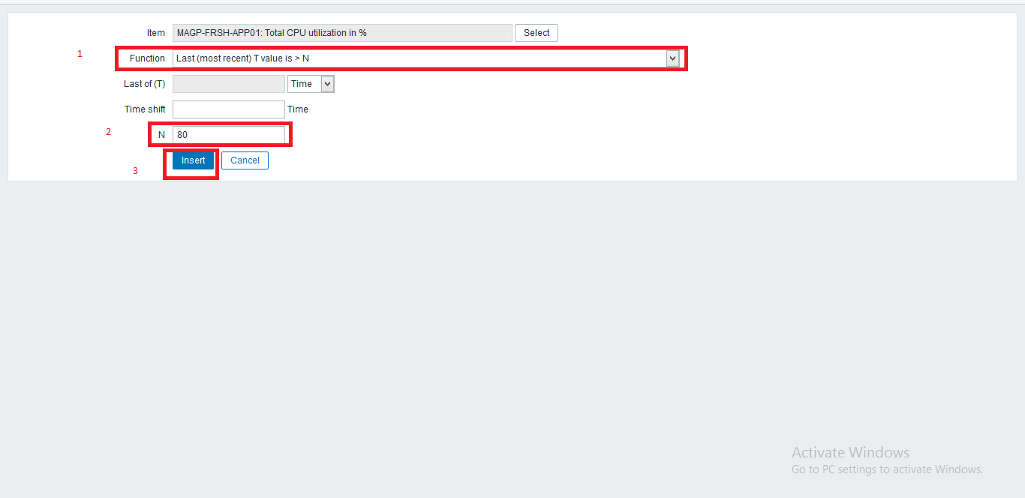

(g)

1. Now check expression of the trigger

2. Select check box to enable this trigger

3. click on Add to add this trigger

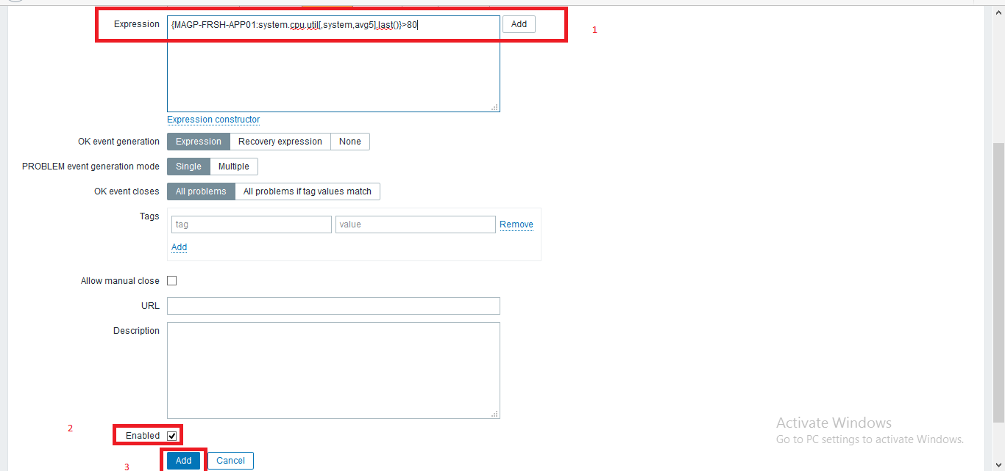

So here we have added a host and then we have created a item for monitoring CPU utilization and we have craeted

a trigger for this item .

4. **Configuration for email alerts notification**

To receive email alerts on the occurrence any event , we need to configure media type and enable this media type for a user .

Steps are following for the media type -

(a) Click on **Administration > Media Types > create media type**

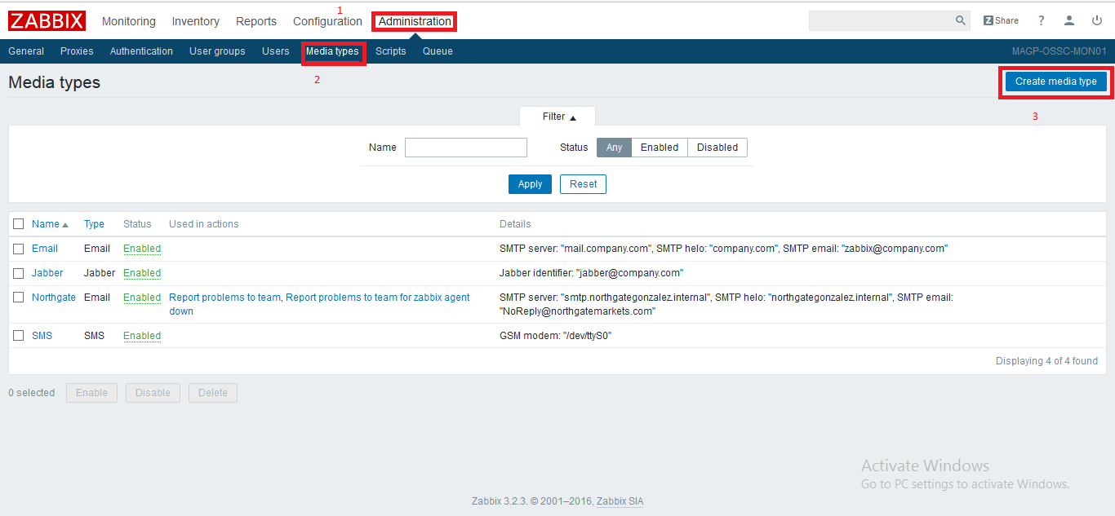

(b)Enter following details for media type

1.Name of Media type

2. Select type of media from drop down list

3. SMTP server name

4. SMTP port number

5. SMTP helo name

6. SMTP email ( sender Email ID)

7. Connection security – None

8. Authentication – None

9. Select check box to enable this media

10. Click on Add to add this .

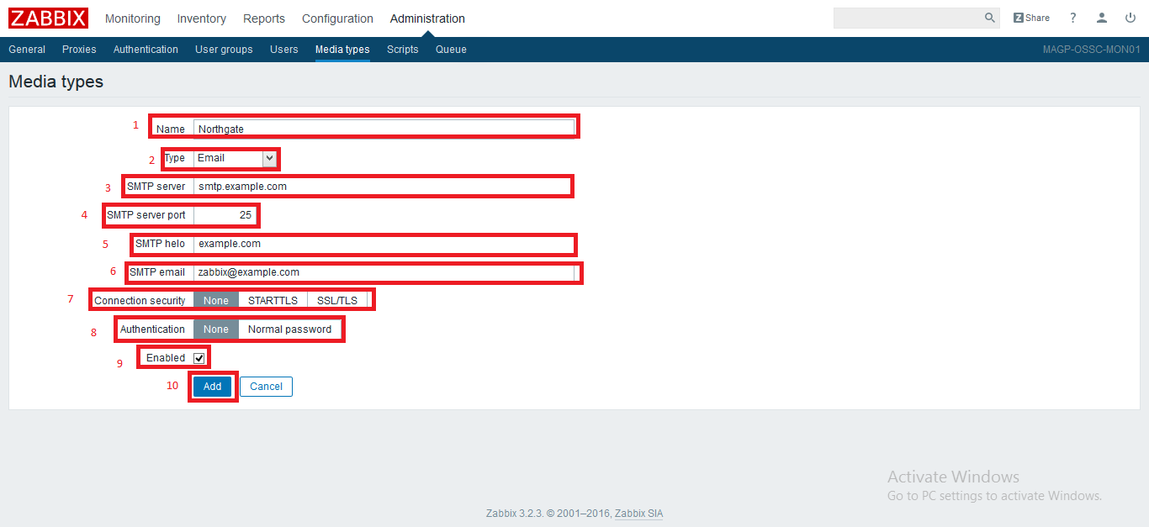

Here we have created a media type for email alert.

(c) Now enable created media type for a user.

Click on **Administration > Users**

Select user Admin

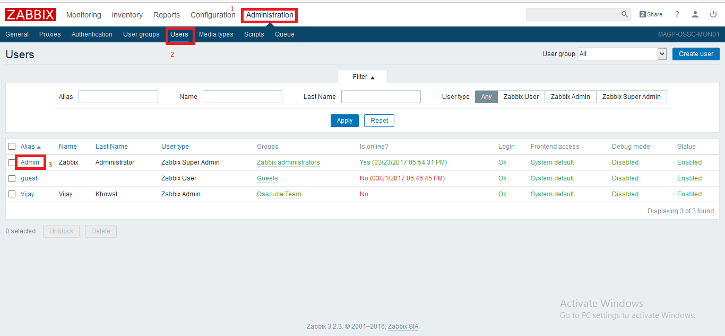

(d) Click on media tab and click on tab to add media type for this user

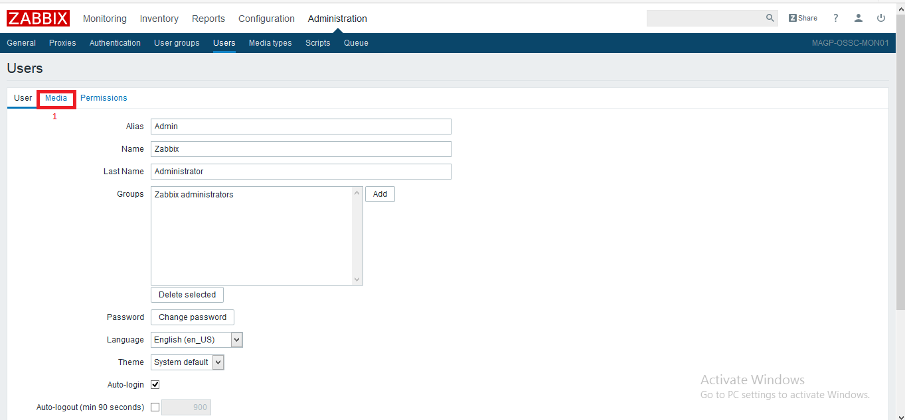

(e) Now enter following details

1. Select media type from drop down list

select that created previously.

2. Send to – Email to receive email

3. select all check box for severities

4. Select check box to enable this media for user Admin

5. Click on Add to add this media for user Admin

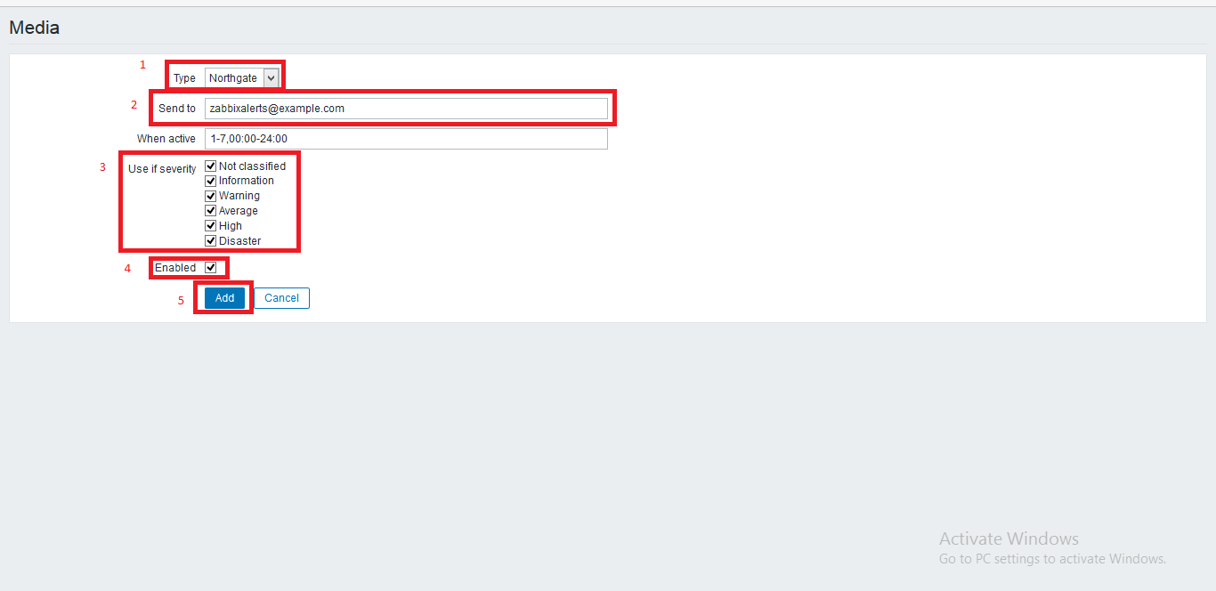

After this Click on Add to add and save the user setting .

5. **Create action for alerts of the event**

Steps to create action for the email notification.

(a) Click on **Configuration > Action > create action**

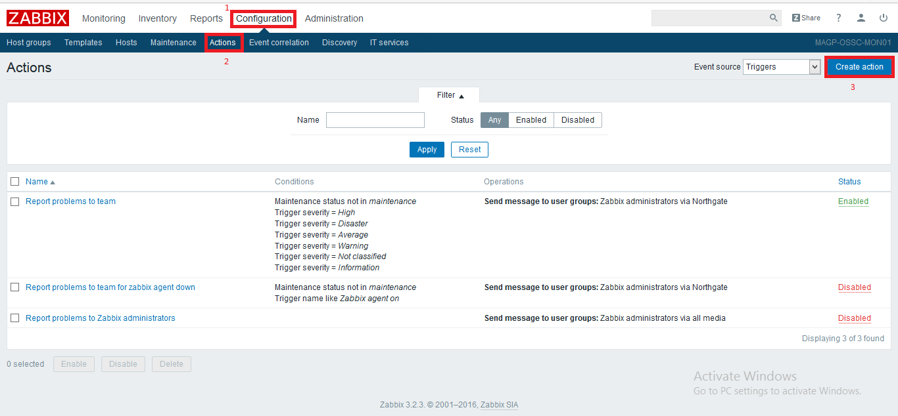

(b) Now on Action tab

1. Name of action

2. Type of calculation

3. Click on Add to add all condition according to all severity.

4. Select check box to enable it.

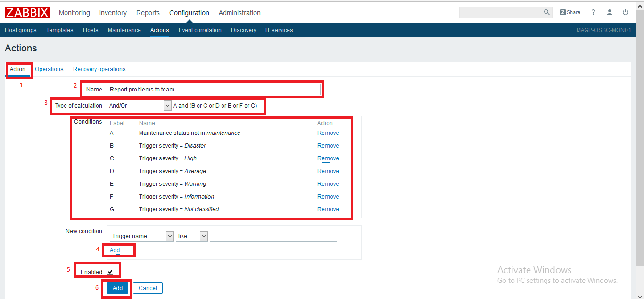

(c) Click on now Operations tab

1. Default operation step Duration

2. Default subject

3. Default message

4. Uncheck box for pause operations while in maintenance

5. Click on new to add operation steps

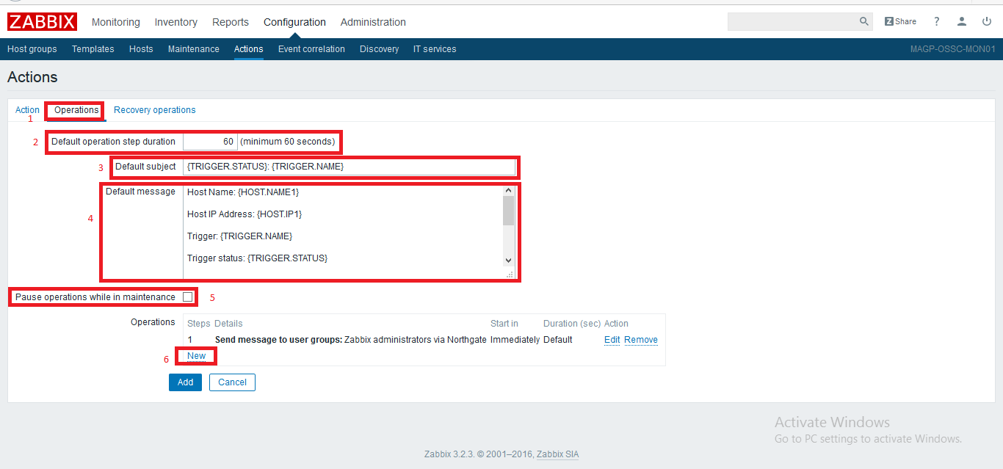

(d) Now enter details for operation

1. Number of steps – 1

2. Step duration – 0

3. Send User – select user to send email

4. Send only to – Media Type that is created before .

5. Check on default message

6. Click on Add to add this operation

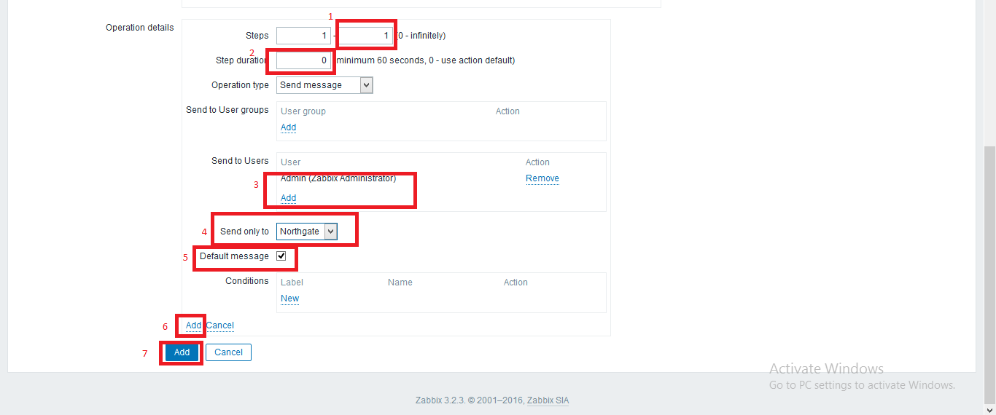

(e) Now click on Recovery operation tab

1.Edit default subject and message .

2. Click on New for operation

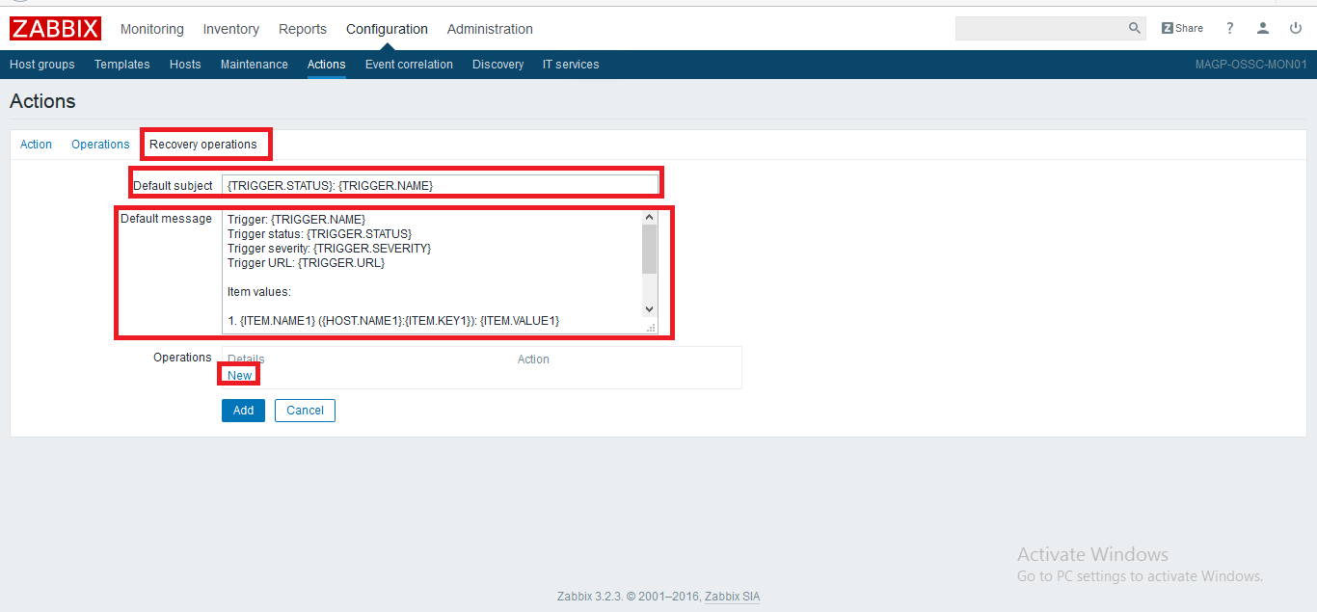

(f)Now edit details for recovery operation

1. Operation type – send message

2. Add user to send email

3. Send only to – Media type

4. check on default message

5. Click on add to add operation

6. Now final click on ADD to add this action

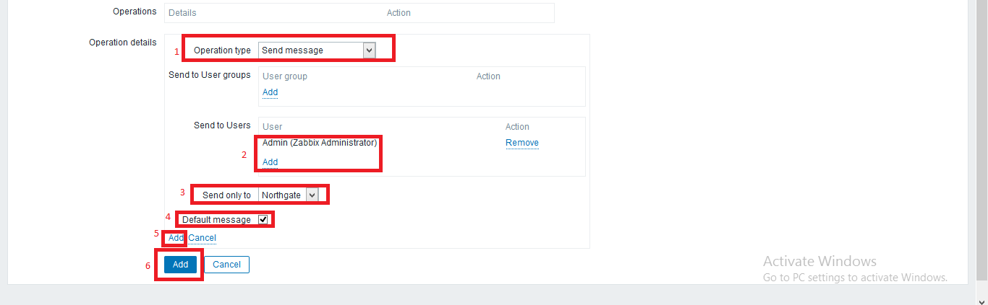

Here new action has been created with email notification for user Admin.

6. We can create custom item for any of the host to monitor any item. So we need to add UserParameter option in zabbix agent configuration file of that host.

Steps are following -

1 .For custom item we need to open zabbix agent configuration file

**#vi /etc/zabbix/zabbix_agentd.conf**

2. Now edit these line below

**UserParameter=cpuuptime.fiveminutes,uptime | sed -e "s/^.*[a-z]: //; s/,//g" | awk '{print $2}'**

save file and restart the zabbix agent

3. #systemctl restart zabbix-agent

4. Now using zabbix server dashboard , we need to add an item similarly we added before.

(a)

1. Item name

2. Type of the item (depend on your requirement)

3. Click on select to add here item key and its value

**Here item key name will be same as the value in UserParameter**

4. Type of information that will be monitored by zabbix

5. Update interval time

6. History storage

7. Trend storage time

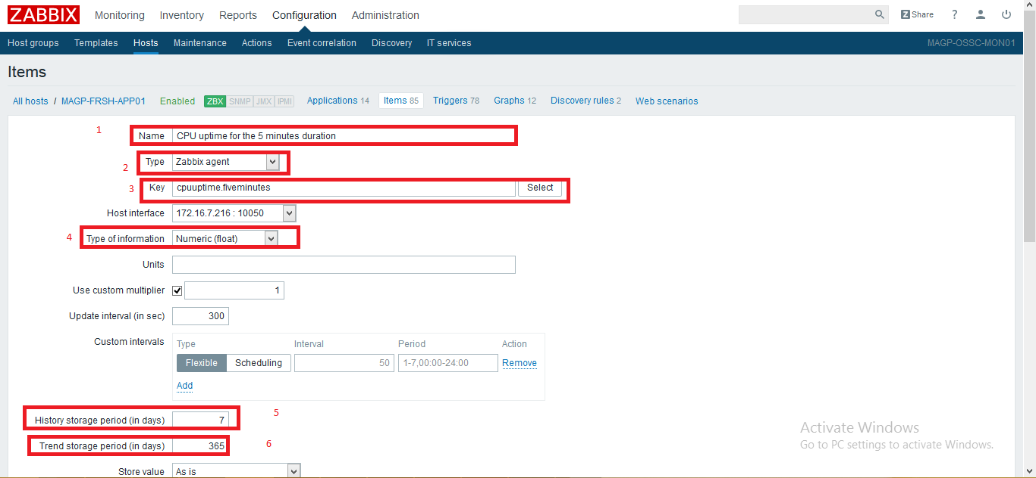

(b)

8. Now select application name

9. select check box to enable this item

10. Click on Add to add this item.

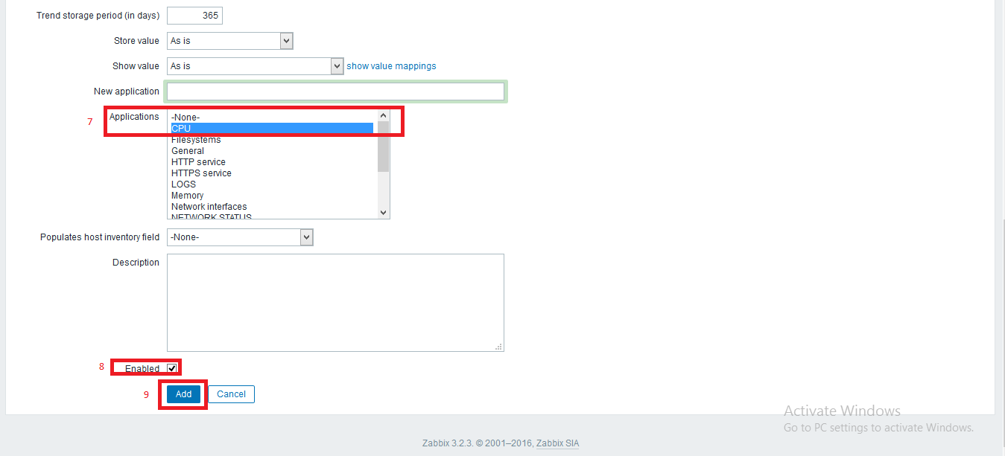

So this custom item will monitor cpuuptime for avarage of 5 minutes.